Board Biography for Leroy (Lee) D. Nunery II
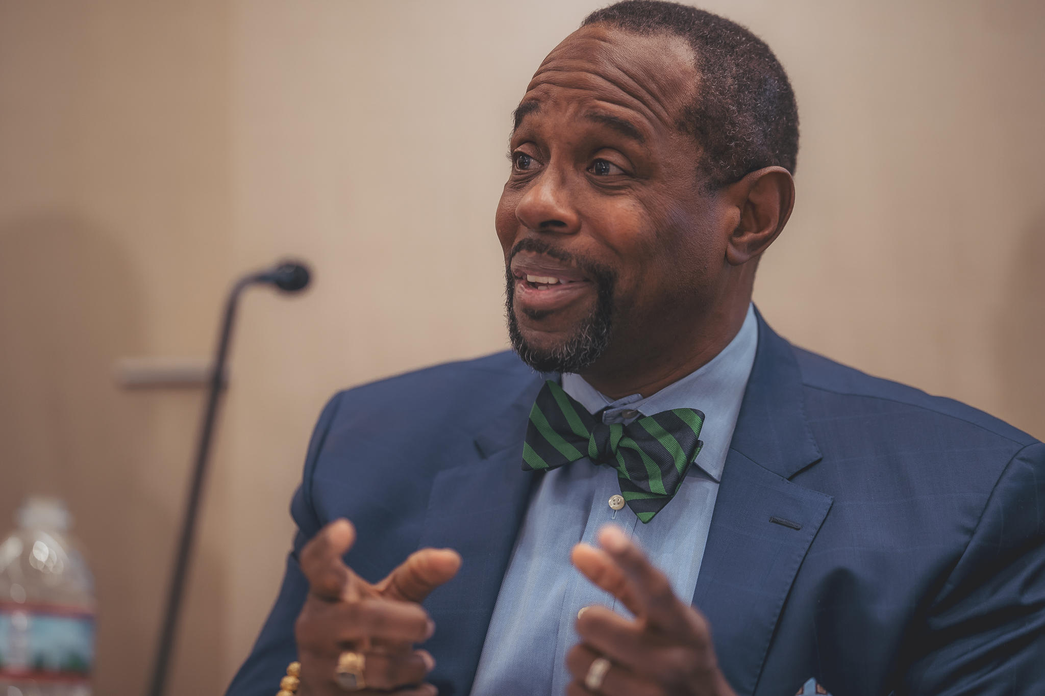
Dr. Leroy (Lee) David Nunery II is an accomplished executive and entrepreneur with a unique breadth of experiences and competencies formed from over forty years in corporate banking and capital markets, higher education, professional sports, charter school management, public education, and with a family-owned electrical contracting firm, Leroy Nunery & Sons, Inc. In 2007, Leroy founded PlūsUltré LLC, a strategic advisory firm with a focus on turnarounds, transformations, growth and innovation planning, resource development, talent development, governance training, and diversity, equity and inclusion (DEI) strategies.

In 2017, PlūsUltré was commissioned by Marsh Companies to author a groundbreaking demographic and psychographic study called “The Journey of African American Insurance Professionals: Past and Present”. Since publication in 2018, the Study has been presented to insurance carriers, agencies, and trade associations, and is recognized for its deep analysis of the industry’s DEI dynamics and acknowledgment of the historic accomplishments of African American practitioners, professionals, and insurance company owners. Based upon the Study’s finding, PlūsUltré provides consulting services to the insurance industry on development and implementation of DEI strategies, exemplified by engagement with the Independent Insurance Agents and Brokers Association (IIABA) as its Executive Diversity Consultant, and Dr. Nunery’s appointment by the Million Women Mentors’ Women in Insurance Initiative as Senior Advisor for Diversity, Equity, & Inclusion to help the organization work toward a more inclusive space for all within the insurance industry. Future versions of the Study will explore the linkages between effective diversity and inclusion practices and corporate performance, supplier diversity, and how DEI programs can affirmatively impact talent identification, selection, and retention.

Dr. Nunery has extensive experience in governance. He currently serves on the boards of Benchmark School, Philadelphia Outward Bound School, Alumni Advisory Board for University of Pennsylvania’s Graduate School of Education Executive Doctorate Program, and the National Council of Washington University’s Gephardt Institute for Civic and Community Engagement. He has previously served on the boards of Blue Cross Blue Shield Association, Inc., Pitney Bowes, Inc., Savoy Bank (New York), and Lafayette College. He is a Lifetime Member of the National Black MBA Association, Inc., and served as National President (1983 - 1987).

Among other recognitions, Dr. Nunery has been awarded the Wallace L. Jones Lifetime Achievement Award by the Consortium for Graduate Study in Management, and the Alumni Achievement and Community Engagement Award from Washington University’s Gephardt Institute. Since 2002, Lafayette College has awarded the Leroy D. Nunery Award for Intellectual Citizenship to a senior student of color for leadership and academic excellence.

Dr. Nunery is a graduate of Lafayette College (B.A., Honors in History, 1977), Washington University (M.B.A., 1979), and the University of Pennsylvania (Ed.D., 2003). He has participated in the Aspen Institute’s Executive Seminar; the Public Education Leadership Program (Harvard); and the Wharton e-Fellows Program (University of Pennsylvania). Leroy frequently speaks on educational access, leadership, and organizational development and has taught at The Fels Institute of Government, University of Pennsylvania (2008 – 2015) and Keller Graduate School of Management (1981 – 1984).

Leroy resides in Wyndmoor, PA, and is an avid golfer and loves to travel. He and his wife Gina Golson Nunery have three adult children, Leroy, Gillian, and Dorothy (Jackie). He is a proud member of Omega Psi Phi Fraternity and Sigma Pi Phi Fraternity.

